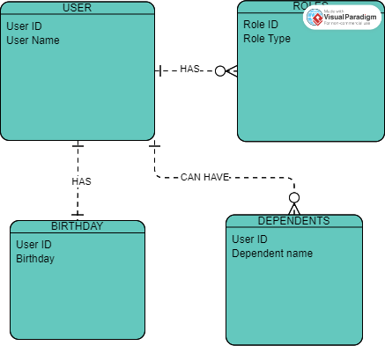

NoSQL

{

"User_Name": "Jackie Scott",

"User_ID": "123456",

"Roles": [

{

"Role_ID": "2",

"Role_Type": "Admin"

},

{

"Role_ID": "4",

"Role_Type": "Release Manager"

}

],

"Birthdate": {

"Date": "04-16-1991",

"User_ID": "123456"

},

"Dependents": [

{

"User_ID": "123456",

"Dependent_Name": "Jay Scott"

},

{

"User_ID": "123456",

"Dependent_Name": "Dan Scott"

}

]

}

I used both an extension on Visual Code Studio to format the NoSQL code and a JSON validator

I use this very often for work and just have it book marked. I'm not sure where the site is to add it on a works cited, so I hope this is ok.